Document Number | MLP1
Document Title | Medico-Legal Bookings
Department Ownership | Medico-Legal
Document Type | Procedure
Department Owner | Emma Raphael
Document Author | Derrick Chan
Last Edited By | Derrick Chan | Lasted Edited On | 13/04/2014

Purpose

The purpose of this procedure is to outline the steps required to perform a booking within Redilegal.

Scope

For any staff member that performs a Redilegal booking.

Reference Documents

Definitions

AMS – Approved Medical Specialist
ED – Emergency Department
FFW – Fitness for Work
FFW01 – Simple Fitness for Work Assessment
FFWP01 – Simple Progress Fitness for Work Assessment
FFW02 – Comprehensive Fitness for Work Assessment
FFWP02 – Comprehensive Progress Fitness for Work Assessment
FFW03 – Complex Fitness for Work Assessment
FFWP03 – Complex Progress Fitness for Work Assessment
FFW04 – Simple Fitness for Work Assessment with OP review.
FFW05 – Comprehensive Fitness for Work Assessment with OP review
FFW06 – Complex Fitness for Work Assessment with OP review
FFWOP – Occupational Physician Fitness for Work Assessment
FTF – Fitness to Fly Assessment
FFWSR – Supplementary Fitness for Work report
FFWF – Fitness for Work Functional Capacity Assessment
FFWJ – Job specific Functional Capacity Assessment
FFWadmin – Administration fee
FFD – Fitness for Duty Assessment
OP – Occupational Physician

IME – An Independent Medical Examination (IME) completed by a Specialist/Approved Medical Specialist. Includes review of all relevant medical information prior to the consult, a comprehensive consultation, and report (two pages) addressing specific questions.

IME1 – An Independent Medical Examination (IME) completed by a Specialist/Approved Medical Specialist. Includes review of all relevant medical information prior to the consult, a comprehensive consultation, and report (three pages) addressing specific questions.

IME2 – An Independent Medical Examination (IME) completed by a Specialist/Approved Medical Specialist. Includes review of all relevant medical information prior to the consult, a comprehensive consultation, and report (four pages) addressing specific questions.

IME3 – An Independent Medical Examination (IME) completed by a Specialist/Approved Medical Specialist. Includes review of all relevant medical information prior to the consult, a comprehensive consultation, and report (five pages) addressing specific questions.

IME4 – An Independent Medical Examination (IME) completed by a Specialist/Approved Medical Specialist. Includes review of all relevant medical information prior to the consult, a comprehensive consultation, and report (six pages) addressing specific questions.

IME5 – An Independent Medical Examination (IME) completed by a Specialist/Approved Medical Specialist. Includes review of all relevant medical information prior to the consult, a comprehensive consultation, and report (seven pages) addressing specific questions.

Flowcharts (Other Images)

Procedures

Fitness for Work Assessments

Making the Booking

In order to book in a Fitness for Work Assessment the employer will need to complete and send through the Fitness for Work Request form, shown below.

Once received REDiLEGAL will link this form to the patient file and confirm the booking via email with the representative booking the assessment.
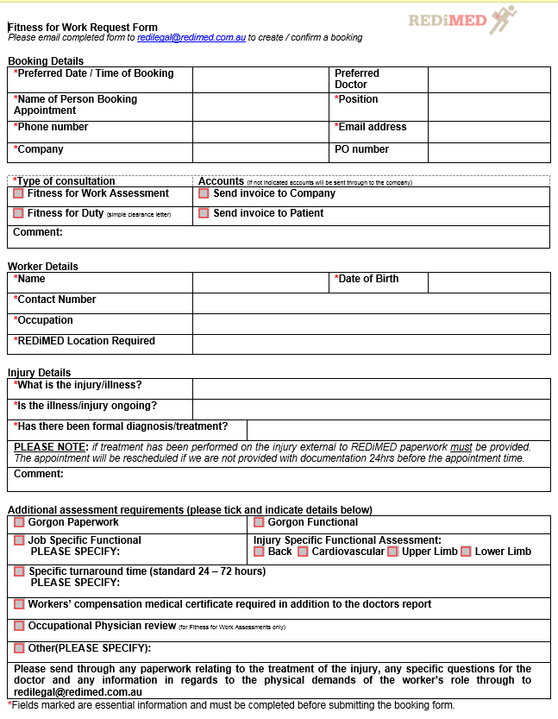

All General Practitioners are available to book in Fitness for Work Assessments. If a specialist is requested this first must be confirmed with the doctor. Complete the step by step procedure to correctly book in a Fitness for Work Assessment:
- Review the booking form to see if any additional assessment requirements have been requested. How to include the additional assessment requirements in the booking are detailed below.

- Read the information provided on the request form to understand the presenting injury/illness. Follow the below rules to allocate enough time for the doctor to see the patient.
One injury | 45min/3 slots
Complex description of injury | 60min/4 slots
Mental health | 60min/4 slots
- In the notes section of the booking please indicate if this is a new patient/new injury by writing ‘Initial FFW.’ If the patient is already a patient at Redimed or have been required previously for a Fitness for Work please state ‘Redimed patient’ or ‘progress FFW’ to ensure that the file is pulled.

- This booking needs to be coloured Fitness For Work

- Fitness for Work assessments should not be booked in the last hour of the doctor’s clinic.
If the client has requested the consultation with an Occupational Physician Redimed currently outsource this appointment. In alliance with Peregrine Medical in Subiaco, the appointment is made and confirmed with the client. Appointments can be book by either;
- Email: admin@peregrinemed.com.au
- Phone: 9380 6500

Gorgon Paperwork

When requested, this general health questionnaire is completed prior to the consult. This is only requested as a site requirement. This form needs to be given to the patient on arrival. When making the booking please write in the notes – ‘Gorgon Questionnaire’. This will prompt reception when checking in the patient that this paperwork is required. All CKJV patients will need to complete this for all Fitness for Work Assessments. This requirement only needs to be indicated in the notes, is not billed for and does not need to be allocated any time in Genie.

Job Specific Functional

All functional assessments are completed by an Exercise Physiologist and measure the workers physical capability to perform his role. Specific to the workers role, this assessment will measure the workers ability to perform all physical demands. The workers’ occupation needs to be noted down in order for the right paperwork to be printed. In the notes please indicate ‘Job Specific Functional – {Occupation}.’ Complete the step by step procedure to correctly book in a Job Specific Functional:
- All Exercise Physiologists are available to book in for a functional assessment, this needs to be booked before the doctors consult.

- Follow the below rules to allocate enough time for the assessment
Job Specific Functional | 105min/7 slots

The last 15 min of this booking is allocated to the exercise physiologist to complete their report. This 15min can overlap with the doctors consult so the patient does not have to wait. See an example below.

- Both bookings for the functional and doctors consult need to be coloured Fitness for Work.

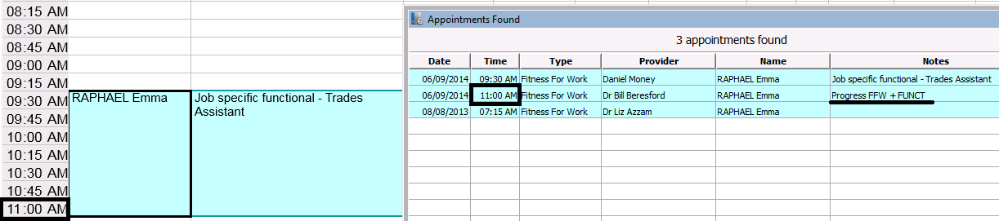

Gorgon Functional

The Gorgon functional is considered a Job specific functional assessment completed on Gorgon paperwork. This is generally requested as a site requirement. When booking this appointment please allocate the appropriate time as detailed above. ‘Gorgon Functional’ will need to be indicated in the notes. If CKJV request a functional assessment this will always be a Gorgon Functional.

Injury Specific Functional

Specific to the workers role, this assessment will measure the workers ability to perform the physical demands only related to the workers injury. The injury specific functional at REDiMED include; upper limb, lower limb, back and cardiovascular. For example if the worker has a shoulder injury, an upper limb functional will be conducted to measure his lifting requirements for his role. ‘Upper Limb Functional’ will need to be indicated in the notes for example.

This is a shorter consult compared to the job specific and whilst the same procedure for making the booking as stated above should be followed, the time allocated from this assessment varies.
Injury Specific Functional | 75min/5 slots
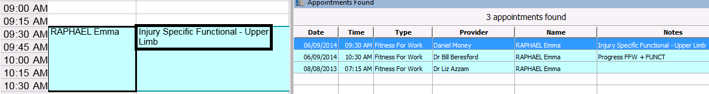

Specific Turnaround

Generally speaking REDiLEGAL will send through the completed report through to the requesting representative within 24 – 72 hours of the consult. If there are circumstances where the report is urgent or there is a specific deadline, this needs to be indicated in the notes. If for example a verbal report is required directly following the appointment please indicate accordingly ‘call Amanda for verbal ph:’

Medical Certificate

A Workers Compensation Medical Certificate may also be requested in addition to the Fitness for Work Report. This is generally due to an open claim or the patient is unsure whether they wish to process the injury as a WorkCover claim. This needs to be highlighted on the request form and a posted note on the patient file for the doctor to complete.

Occupational Physician Opinion

This will be requested by the employer to meet site requirements. For example all Workers’ on Barrow Island will require an Occupational Physician Approved report following an injury or illness. The consult and report is completed by a REDiMED Medical Practitioner. Once completed the file and report is sent through to the Occupational Physician, he reviews all documents and sends back a short report. The Occupational Physician report is included in the initial report and sent through to the employer.

Preparing for the Appointment

The files for the Fitness for Work assessments need to be made up the day before the appointment. This is to ensure all the correct paperwork has been received and is printed for the consult. Please see below a check list to ensure all the correct paperwork is printed for the consult. If the paperwork received is insufficient please email the company representative who booked the appointment:-

- Booking form – with all sections completed

- On the booking form where is asks ‘has there been a formal diagnosis/treatment?’ ensure there is paperwork addressing the treatment of the patient’s injury or illness.

- If a functional assessment is requested please print the corresponding paperwork located at the below address:
I:\Health and Wellness\Admin\Reports\Fitness for Work

- If the company have requested a job specific functional and the paperwork cannot be found, please follow the steps below:

  - Call an exercise physiologist to see if any current functional paperwork would match the physical demands of the occupation
  - Email the company representative who booked the appointment to send through the physical demands of the worker’s role
  - Email through the physical demands to the exercise physiologist that the functional assessment is booked with
  - The exercise physiologist will make a functional assessment based on this paperwork

- A Fitness for Work billing code needs to be in every Fitness for Work file, these are located below:

I:\Redilegal\Administration\Price Lists

Completing the report

Once the report has been completed and sent through from the typists please follow the following check:

Beginning

- The date on the report needs to reflect the date you are sending the report. This needs to be written in full – 27 October 2014.
- PRIVATE & CONFIDENTIAL – needs to be written on all Fitness for Work assessments
- Ensure the report is addressed to the person identified on the booking form. Where possible include the following information:

  - Name
  - Job title
  - Company name
  - Email address

- The patients name in bold below is auto filled form the information provided in Genie. If the patient has more than one claim the details filled in automatically will be from the first claim. Ensure this information is correct.
- If there is no claim number, in this space please write Fitness for Work

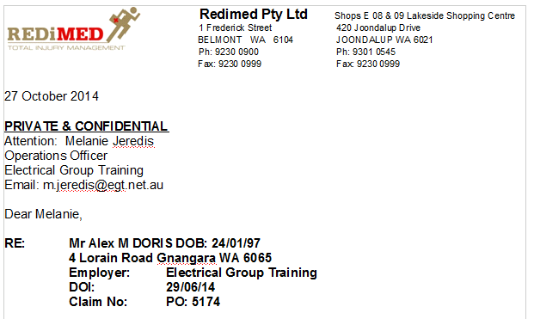

Middle
- The patient should not be referred to by their first name. It should read Mr Doris
- The text needs to be justified
- Any heading in the report needs to be bold and italics with no space after
- Ensure the reports ends commenting on the patient’s ability to return to work. If this is not completed put the file back up with the doctor to complete.
- If an exercise physiologist has also completed the report ensure the two reports are consistent.

End

The report should end with:

Should you have any further concerns, please do not hesitate to contact REDiMED on __ {number of clinic}.
The doctor’s signature should be imported to the report with;

Doctor’s name
Tile
Provider number

Sending the Report

Before the report is sent ensure that all the information on the booking form has been completed as requested by the client. If something has been missed ensure the client is kept up to date. All documents pertaining to the assessment are emailed through in a pdf format to the client requested on the booking form. The invoice for the assessment is then created and either posted or emailed through depending on the agreement with the company.

Please note: there is a list of companies on I: Drive {I:\Redilegal} that have requested invoices to be emailed through. Ensure you save the invoice in the correct folder for this to occur. The accounts department will email these as required. Ensure the invoice is saved in line with the example provided below:

J Smith dr 14-10-14
J Smith funct 14-10-14

Do not post the reports through to the company. These documents are private and confidential and will only be emailed through to the person indicated. If another representative from the company is requesting a copy of the report they are to ask the person who booked the assessment, Redimed will not release this to anyone else.

Invoicing

The doctor completes a billing sheet following a Fitness for Work Assessment recording the time taken to complete the report and level of complexity.

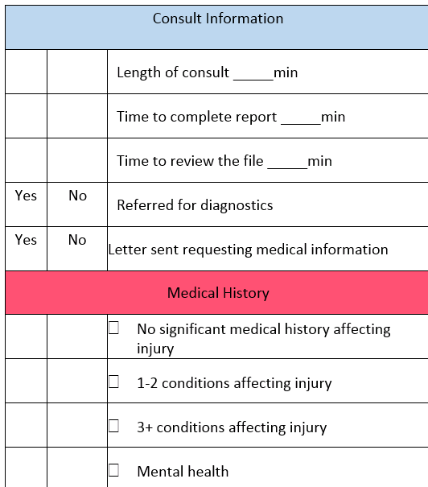

When creating the invoice use the subcategories below to determine which category the assessment belongs to. When the total time is close to the cut off for each category use the complexity and past medical history sections as a guide. In the notes section of the invoice please state the reasoning for selecting the category ie. 50min or less to complete report, 2 affecting injuries for a comprehensive assessment.

 | Simple | Comprehensive | Complex
Total Time:  Length of consult + time to complete report + time to review file | - 50min or less | - 51min – 85min | - 86min +
Past medical history | - No significant | - 1-2 conditions | - 3+ conditions
Complexity | - Sufficient information provided | - Not enough medical information provided - 1 follow up required | - Not enough medical information provided - 2+ follow up required
 | - 0 – 1 Diagnostic scans | - 2 – 3 Diagnostic scans | - 4+ Diagnostic scans
 | - No surgery | - 1 operation | - 2+ operations
 | - No treatment, GP letter, ED referral | - 1 Specialist review | - 2+ Specialist review
The categories above have been created from an average of the reports that have been completed in 2014.
 | Simple | Comprehensive | Complex
Length of consult | 30min | 45min | 1hr +
Time to complete report | 15min | 30min | 40min
Time to review file | 5min | 10min | 15min
Total | 50min | 85min | 115min

Below is a list of codes and prices used for Fitness for Work Assessments. Before the invoice is created please refer to the booking form as a guide of what needs to be invoiced as each additional assessment requirement can incur a cost. Please note: when a Workers’ Compensation Medical Certificate has been requested and a claim has been accepted, the certificate is invoiced and posted through to the insurance company. See below.
Medical Certificate | When a Worker’s Compensation claim has been accepted | $70.10 | GP3
 | No existing Worker’s Compensation claim | No charge

Fitness For Work Assessment - Schedule of Fees
Service | Description | Fee*
(FFW01) Simple Fitness for Work Assessment | Simple fitness for work consultation/file review with a General Practitioner. Includes review of all relevant medical information and report. | $210
(FFWP01) Simple Progress Fitness for Work Assessment | Simple progress fitness for work consultation with a General Practitioner following an initial assessment by the same practitioner. Includes review of all relevant medical information prior to the consult, a comprehensive consultation, and report. | $168
(FFW04) Simple Fitness for Work Assessment with OP review | Simple fitness for work consultation with a General Practitioner. Report reviewed by an Occupational Physician. | $410
(FFW02) Comprehensive Fitness for Work Assessment | Comprehensive fitness for work consultation / file review with a General Practitioner. Includes review of all relevant medical information and report. | $420
(FFWP02) Comprehensive Progress Fitness for Work Assessment | Comprehensive progress fitness for work consultation with a General Practitioner following an initial assessment by the same Practitioner. Includes review of all relevant medical information prior to the consult, a comprehensive consultation, and report. | $336

(FFW05) Comprehensive Fitness for Work Assessment with OP review | Comprehensive fitness for work consult with a General Practitioner. Report reviewed by an Occupational Physician. | $640
(FFW03) Complex Fitness for Work Assessment | Complex fitness for work consult / file review with a General Practitioner. Includes review of all relevant medical information and report. | $605
(FFWP03) Complex Progress Fitness for Work Assessment | Complex progress fitness for work consult with a General Practitioner following an initial assessment by the same practitioner. Includes review of all relevant medical information prior to the consult, a comprehensive consultation, and report. | $484
(FFW06) Complex Fitness for Work Assessment with OP review | Complex fitness for work consult with a General Practitioner. Report reviewed by an Occupational Physician. | $845
(FFWOP) Occupational Physician Fitness for Work Assessment | Comprehensive fitness for work consultation performed by an Occupational Physician with accompanying report. | $1210
(FTF) Fitness to Fly Assessment | Fitness to fly assessment performed by a General Practitioner | $77.11
(FFWSR) Supplementary Fitness for Work report | Supplementary report following a fitness for work assessment and initial report. $250 per page competed by a General Practitioner, $500 per page completed by an Occupational Physician.  *calculated: word count/350 x $ | Per page
(FFWF) Fitness for Work Functional Capacity Assessm | Injury specific functional capacity assessment performed by an Exercise Physiologist | $99
(FFWJ) Job-specific Functional Capacity Assessment | Job specific, full functional capacity assessment of task demands performed by an Exercise Physiologist | $220
(FFWadmin) Administration fee | Applied at REDiMED’s discretion for assessments requiring extensive coordination of appointments, additional results / report follow-up, urgent turn-around time | $60
* Prices are inclusive of GST

Fitness for Duty

Making the Booking

Fitness for Duty assessments are booked the same as Fitness for Work assessment. The booking form is completed and sent through to Redilegal@redimed.com.au. The appointment can be made over the phone if convenient of the client, however the booking form needs to be completed to secure the booking. Please note this assessment is for simple injuries only. A functional assessment or Occupational Physician review cannot be requested for this type of booking.

The length of the consult will always be 30min. the appointment is to be coloured Fitness for Duty with initial or progress in the notes.
The injuries or illnesses that would be applicable for the Fitness for Duty assessment can include the following:

- The cold or simple sickness (gastro, tummy bug)
- Simple sprains
- Injuries with no treatment needed or given

Preparing for the Appointment

A templated Medical Certificate has been created for this assessment. This is located:
I:\REDIMED\ADMINISTRATION DOCS\FORMS\Fitness for Work

This needs to be printed for the file along with the booking form and any additional information provided by the company.

Sending the Medical Certificate

This is a hand written certificate that will be completed by the doctor during the consultation. Redilegal will scan this in and email it through to the client after the appointment. Companies may have their own paperwork to be completed during these consults (eg Theiss), in these circumstances the medical certificate does not need to be completed.
Before sending off the paperwork ensure the doctors provider stamp, signature and date of the consult are filled in correctly.

Please note: If the presenting condition is too complex to be assessed with a Fitness for Duty, this needs to be indicated by the doctor by ticking the box ‘I will need to review worker again for full fitness for Work Assessment due to the complexity of the injury.’ This is simply a recommendation by the doctor to the company. The assessment will only be booked in if requested by the company.

Invoicing

There is one set price for this assessment. The invoice is created and posted/emailed as soon as the certificate has been sent.

Genie Code: | Description: | Price
FFD | Fitness for Duty Assessment: consultation with Doctor and completion of Fitness for Duty Medical Certificate on Redimed paperwork or company specific paperwork. | $140 ($GP1 + GST)  open to suggestions

Independent Medical Assessment
Making the Booking
An Independent Medical Examination can only be booked in with a specialist doctor. Please see below a list of what doctors completed these assessment and the area of specialty.

Dr Adrian Brooks | Plastic cases; hand, facial & skin
Dr Daniel Luo | Plastic cases; hand, facial & skin
Dr Matthew Scaddan | Lower limb orthopaedic
Professor René Zellweger | All orthopaedic
Dr Paul Khoo | Upper limb orthopaedic
Dr Toby Leys | Lower limb orthopaedic
Dr Matthew Lawson-Smith
(October 2014)

A minimum of 45min needs to be allocated to this booking. This can be increased based on the doctor’s request or complexity of the assessment.

How the assessment is booked
In order for the assessment to take place the assessing Doctor needs to receive AMS1 form from either the insurance company or law firm. The assessment may not go forward without this form. The Admin team will book the appointment with the appropriate specialist and Medico-Legal Assistant.

This will be a formal request from either the insurance company, employer or law firm needs to be received 1 week prior to the assessment. This generally included specific questions that need to be addressed by the doctor as well as all medical documentation from the treatment of the injury. Please note that a private patient cannot book in for an Independent Medical Examination due to the requirement of a formal request.


Preparing for the Appointment
The paperwork for the assessment needs to be sent through at least one week before the appointment. Admin need to ensure that the questions and the patient file is linked and uploaded to DropBox for the doctor to view.
Please note DropBox is used by all staff in the Redielgal team to access the information relating to the assessment and completion of the report. This is broken down by doctor.
Login: kcassidy@redimed.com.au
Password: creative1
Each doctor will have the following folders:
- AMS to be seen (information to all assessments arranged by the date of the appointment)
- Ash (list of documentation provided for the assessment, used by Admin, arranged by date)
- Greer Hall (each Medical Legal Assistant will have their own folder where their part of the assessment is uploaded to for the doctor to use to complete the assessment)
- Heath Prentice
- Melanie Kerr
- Ready for admin (where the doctor uploads the final assessment)

Completing the Report

The formatting rules outlined in the Fitness for Work section of this policy apply to all reports including the Independent Medical Examination. An IME template has been created to ensure all reports are consistent. All the documentation that has been sent through by the requesting third party needs to be listed before the body of the report begins. This would have already been completed by Admin support (Ashleigh O’Reilly), log into DropBox to copy and paste this information into the report. Ensure that all of the questions are answered in full sentences. For example if the doctor has indicated N/A to a questions please write not applicable. Some doctors will answer a question by writing yes… ensure to finish the sentence with words from the initial question.

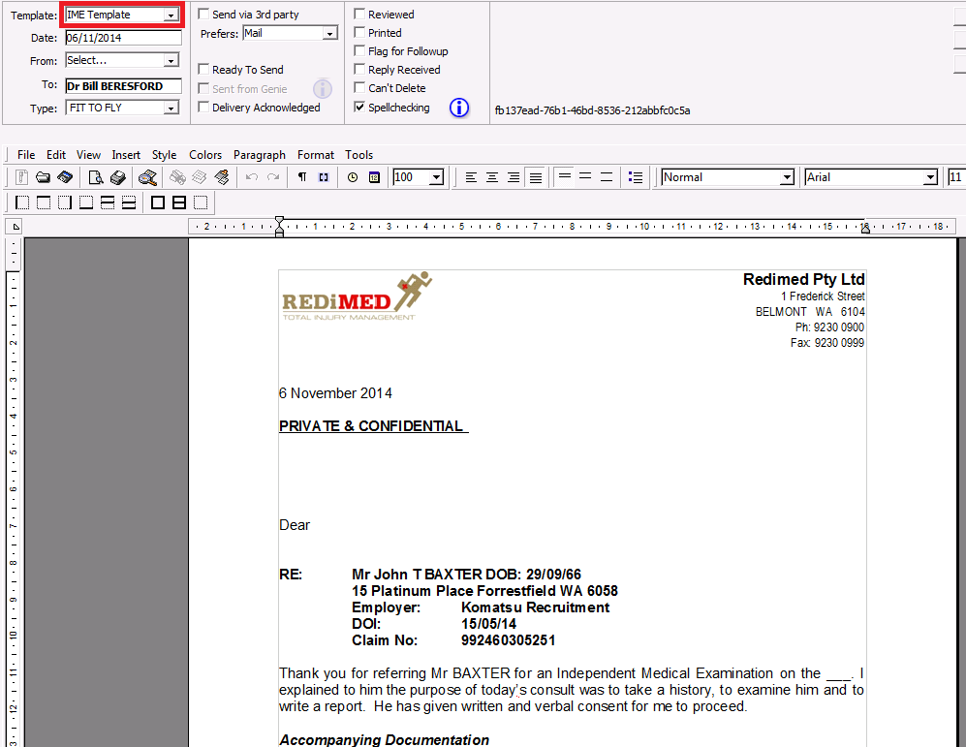

Sending the Report

Print and cute PDF the report and email this through to the requesting third party. If photos are included as an appendix to the report ensure to scan in the document with the photos. The report can then sent as one document.

Invoicing

In order to determine how many pages the report is, we follow the below calculation:
Total words / 350 = pages
If the calculation leaves us with decimal points we will round down for anything ≤.5 and round up for anything >.5

If photos are used to assist with the report each photo is added to the total words where every photo = 100 words.
Independent Medical Examination - Schedule of Fees
Service | Description | Fee*
(IME) Standard Independent Medical Examination | An Independent Medical Examination (IME) completed by a Specialist/Approved Medical Specialist. Includes review of all relevant medical information prior to the consult, a comprehensive consultation, and report (two pages) addressing specific questions. | $1,650
(IME1) Standard Independent Medical Examination | An Independent Medical Examination (IME) completed by a Specialist/Approved Medical Specialist. Includes review of all relevant medical information prior to the consult, a comprehensive consultation, and report (three pages) addressing specific questions. | $2,150
(IME2) Comprehensive Independent Medical Examination | An Independent Medical Examination (IME) completed by a Specialist/Approved Medical Specialist. Includes review of all relevant medical information prior to the consult, a comprehensive consultation, and report (four pages) addressing specific questions. | $2,650
(IME3) Comprehensive Independent Medical Examination | An Independent Medical Examination (IME) completed by a Specialist/Approved Medical Specialist. Includes review of all relevant medical information prior to the consult, a comprehensive consultation, and report (five pages) addressing specific questions. | $3,150
(IME4) Complex Independent Medical Examination | An Independent Medical Examination (IME) completed by a Specialist/Approved Medical Specialist. Includes review of all relevant medical information prior to the consult, a comprehensive consultation, and report (six pages) addressing specific questions. | $3,650
(IME5) Complex Independent Medical Examination | An Independent Medical Examination (IME) completed by a Specialist/Approved Medical Specialist. Includes review of all relevant medical information prior to the consult, a comprehensive consultation, and report (seven pages) addressing specific questions. | $4,150
*Prices including GST

Permanent Impairment Assessment

Making the Booking

The Permanent Impairment Assessment can only be booked with an Approved Medical Specialists. See below a list of doctors able to complete this assessment.

Dr Hanh Nguyen | All injuries
Dr Adrian Brooks | Plastic only
Dr Matthew Scaddan | Lower limb orthopaedic
Professor René Zellweger | All Orthopaedic
(October 2014)

This is generally a 30min consult and a Medical Legal Assistant needs to be allocated to each booking.
In order for the assessment to take place the assessing Doctor needs to receive AMS1 form from either the insurance company or law firm. The assessment may not go forward without this form. The Admin team will book the appointment with the appropriate specialist and Medico-Legal Assistant.
The Medico-Legal Assist role is to assist the doctor with the consult, taking down the appropriate medical history and any measurements required for the assessment. Please see below the current list of Medico-Legal Assistants
Greer Hall | Manager - Medico-Legal Assistant
Heath Prentice
Melanie Kerr
Michael Di Pardo
Tennika Brown
Emily Orzel
Phoebe Barrow | Casual / cover
Emma Minson | Casual / cover
(October 2014)

- Preparing for the Appointment
- Completing the Report
- Sending the Report
- Invoicing

Appendices

